# Report for Bennett Bertin-Vitlar (2024-10-01 to 2024-10-31)

Average Bat Speed: 41.06

Average Rotational Acceleration: 4.14

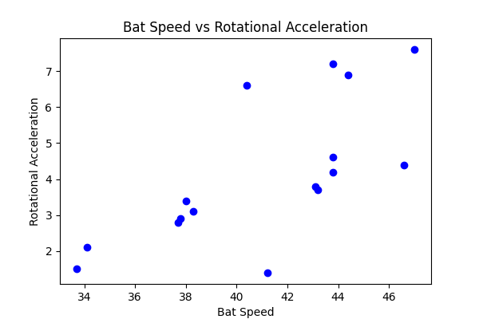

## Comments

Add comments here...